**PC & BC- Interview Questions**

Q1. What are the main entities in PolicyCenter?

Ans.

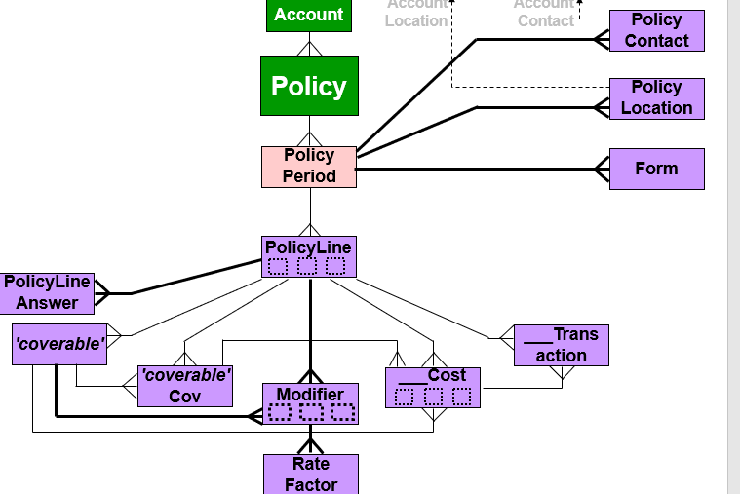

Q2. What is the different status account have?

Ans. Pending, Active, Withdrawn

Q3. What is the purpose of an UW issue?

Ans. An UW issue is designed to collect risk information about the submission. This information could cause the submission to be processed differently.

Q4. How many pre-renewal directions can policy have?

Ans. A policy could have any number of pre-renewal direction, only one active pre-renewal direction.

Q5. What are the transaction requires new quote to be generated?

Ans. Submission and Change

Q6.What are the refund methods in policy center?

Ans. Flat, Pro Rate & Short Rate.

Q7. Is the effective date of reinstatement job required to match with effective date of cancelation job?

Ans. Yes

Q8. Name the three ways in which availability can be specified ?

Ans. Availability tables, Availability script, Grandfathering

Q9. What is the relation between Product and PolicyLinePattern ?

Ans. Product to PolicyLinePattern is many-to-many.

Q10. What are the modifier data type ?

Ans. Boolean, Date, Typekey , Rate(decimal)

Q 11. What are the two basic question types?

Ans. Underwriting and Eligibility

Q.12. What is an Activity pattern ?

Ans. An activity pattern is a description for how to create a specific type of activity.

Q13. When can a form be added to policy ?

Ans. A form can be added to a policy only during transaction.

Q14. Where are the underwriting issues displayed ?

Ans. The underwriting issue are displayed on the Risk Analysis under the tab – UW Issue.

Q15. How many roles can a given user have ?

Ans. A user can have any number of roles from zero to many. A user must have at least one role in order to do something.

Q16. Name the transaction which become effective after end date?

Ans. Rewrite

Q17 What is meant by rescinding a cancellation??

Ans-Whenever a cancellation is scheduled (pending cancellation),we have the option to rescind the cancellation. Rescinding a cancellation means to undo a cancellation before the cancellation job is completed, in case the reason for cancellation has been rectified.

Q18. What is coverage term and what are its types??

Ans. A coverage term is a statement or a value that defines the extent or limit of the coverage. There are five types of cove term we generally used are

Direct, Type key, Package, Generic, Option

Q19. What is Policy Period and Policy Term??

Ans. The Policy Term entity represents one contractual period for the policy. There is only one Policy Term entity for each contractual period.

The Policy Period entity stores information for a specific revision of the contractual period of a policy. A revision occurs anytime a job occurs on a policy.

Q20. What is Billing Lifecycle?

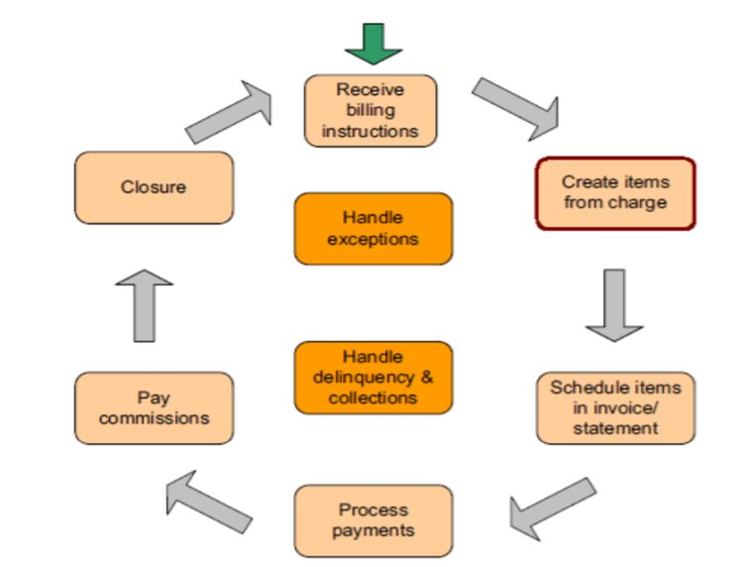

Q21. What happens if a payment is overdue?

Ans. The delinquency workflow associated with account billing plan is started.

Q22. What define how charges are allocated to invoices?

Ans. The payment plan associated with policy.

Q23. What is the status of invoices created from new billing instruction ?

Ans. Planned

Q24. What are the different statuses an invoice can have ?

Ans. Planned, Billed & Due

Q25. When does an account automatically become delinquent ?

Ans When an invoice payment is overdue.

Q26. What should you check before closing a trouble ticket?

Ans All the activities for trouble ticket have been completed.

Q27. What type of commission can manual payment be made ?

Ans. Standard commission & Bonus commission.

Q28. How are policy transaction entered into BillingCenter?

Ans. Policy transaction are entered into an external PAS, where billing instruction are created. PAS sends then to BillingCenter via the billing instruction API

Q29. How do you temporarily suspend commission payments from a policy ?

Ans. Create a trouble ticket on the policy with commission policy earning held.

Q30. Name two ways a producer can be created ?

Ans Producer are created through a batch process or manually through New Producer wizard.